Bash Scripting & Linux Shells (10 Qs)
Shell Types & Configs
- Common shells: bash, sh, zsh, csh
- Config files:
  - System-wide: /etc/shells, /etc/profile
  - User: ~/.bashrc, ~/.bash_profile, ~/.profile
- Check current shell: echo $SHELL
Debugging
- Trace commands: bash -x script.sh
Signals
- Ctrl+C → SIGINT
- Trap signal: trap 'echo "Caught Ctrl+C"' SIGINT
Logic & Control
- if [ condition ]; then ... elif ... else ... fi
- case $var in pattern) ... ;; esac
Variables
- Define: VAR=value
- Export: export VAR=value
- Scope: shell vs environment vars (env to show)
Permissions
- Make executable: chmod +x script.sh
- Run with ./script.sh

Ansible & Automation Fundamentals (19 Qs)
Purpose
- Automation, repeatability, reduce errors
- Agentless via SSH
Key Concepts
- Inventory: hosts file (lists servers)
- Playbook: YAML file describing tasks
- Role: reusable task collection
- Module: atomic action (e.g., copy, yum)
CLI Commands
- ansible all -m ping → test connectivity
- ansible-playbook site.yml → run playbook
- ansible-doc <module> → view module docs
- ansible localhost -m setup → gather facts
Execution & Behavior
- Idempotency: same result on multiple runs
- Order: top-down within plays
- Facts: system info used as variables
- Variable Scope: global → play → host → task
Jinja2 Templates
- {{ variable }} interpolation
- Loops & conditions for config generation

YAML Syntax & Playbooks (6 Qs)
YAML Basics
- Start with ---
- Data: key: value, list: - item
- Supports nested structures (dicts/lists)

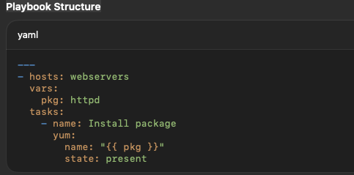
Prompts & Flow
- vars_prompt: → ask for runtime input
- Indentation = structure
- Execution = top-down

Cloud Computing & AWS Services (15 Qs)
Cloud Basics
- Benefits: scalability, cost efficiency, elasticity
- IaaS: Infrastructure as a Service (VMs, storage, networks)
Core AWS Services
- EC2: virtual servers
- S3: object storage
- VPC: private network
- IAM: identity & access management
- SNS: messaging/notifications
- CloudFormation: infrastructure as code
CloudFormation
- Components:
  - Template (.yaml/.json)
  - Stack = deployed resources
  - Parameters/Outputs: dynamic inputs & exports
Storage Classes
- S3 Standard → frequent access
- S3 IA → infrequent access
- Glacier Deep Archive → long-term storage
Deployment Tools
- CodeDeploy: automates deployments
- Terraform: multi-cloud IaC tool (in reading)

Reading Focus
- PPTs: AWS Intro, CloudFormation, Terraform
- Textbook: Ch.1 (pp. 1–50)
- Modules: 4-R2 (CloudFormation), 4-R3 (Terraform)

